**CSC 648-848 section 01**

**Milestone 3 on-line review template**

**Fall 2018**

**\*\*\*\* Please fill out this template, convert it to PDF and mail as attachment to** [**Petkovic@sfsu.edu**](mailto:Petkovic@sfsu.edu) **by 11/16/18 noon. You will get feedback soon after. Anthony will do off-line review as per M3 Appendix II template \*\*\*\***

**In subject line of your e-mail put**

**“CSC 648-848 01 M3 online review Team N”**

**Team: 01 Lead: Marcus Mertilien**

**Date: November 16, 2018**

1. **Please briefly answer each question below:**
   1. *Teamwork*: is the team working out, any related issues
      1. *The team is having issues communicating*, not all members are active on Slack, informing others of their current work status. Trello was implemented to help combat communication issues, but again some team members are not taking full advantage of the communication tools provided.
   2. *Risks*: list all actual (not hypothetical) risks (schedule, technical, skills etc.) and plans how to resolve them OIR ask for help.
      1. *Technical*: We are having trouble figuring out how to pass data between pages using React. React is not originally designed for multiple pages, but for single page applications. We are looking for online solutions, but worst-case scenario we will fall back to a single page application model. We’ve also found that callbacks are one method of passing information between components.
   3. *Coding practices*: Have you decided which coding style to use and actually use it? Make sure you use header comments and some code inline comments too.
      1. *We have yet to decide on a defined coding style, however as team lead I am trying to enforce some basic structure to minimize a drastic refactor*.

* 1. *Usage of proper SE code management practices in github*

Do you have master branch that contain only tested code and is carefully managed?

* Yes, master is locked and controlled by the team lead. Once all testing and development is finished for a milestone, staging is then merged into master.

Do you have development and feature branches

* Yes, each developer is required to branch from our staging branch first before pursuing new features.

Are you doing any code review?

* Yes, developers are strongly encouraged to create a pull request before merging code into staging. This provides a chance for code reviews, time permitting.

Are your comments on github code commits meaningful to reflect enough details?

* Yes, most comments are meaningful enough that you can understand the changes between commits. If time permits I would like to squash the commits for a cleaner working tree.

Are all team members committing on github individually

* Not all team members have contributed meaningful code. Those who have contributed have made meaningful commits and followed the merging process.

* 1. *How did you address site security and safe coding practices:*

Are PW encrypted/hashed

* Passwords will be encrypted but did not make it in time for this milestone. Storing passwords in plain text is an obvious mistake, and a production version will enforce password encryption.

Are you doing any input validation on search text entry as specified (<40 alphanumeric characters?

* The search bar is currently limited to 20 characters of input. We will also apply character limits to all input fields.
  1. *Digital content* (e.g. images, video) – have you obtained enough (total of 30 or so) images for e.g. 4-5 product categories for your demo, royalty free
* The database as it is currently is only populated with 10 or so items. Over the Holiday break the database will be populated for proper testing.
  1. Anything else
* Based on this milestone, I am not happy with the performance of Team01. I believe team members do not understand the gravity of this project, and subsequently have made this class a last priority. Communication has become extremely difficult. Deadlines have been ignored, and productivity has suffered. While the work load is now heavy, it is doable with the members who are contributing.

1. **Provide URL to home page, running from your server so it can be tested (ensure UI implementation is responsive)**
   1. [**http://gatortrader.herokuapp.com/**](http://gatortrader.herokuapp.com/)

1. **Provide PDF screen shots, ONE PER PAGE, of the following screens (they have to be real coded pages but not necessarily connected to back end)**

* Home page

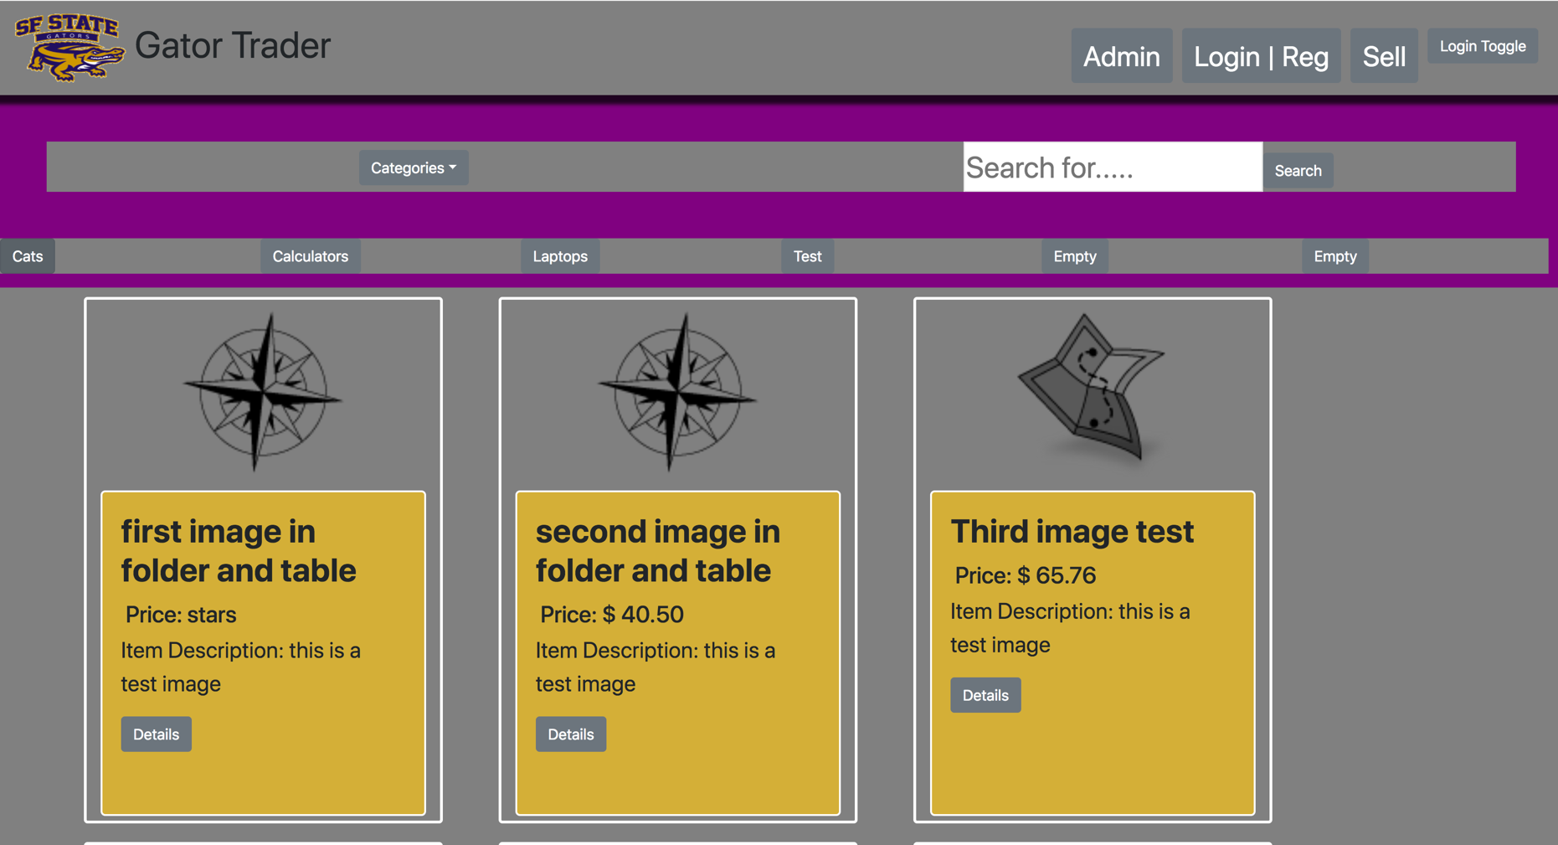

* 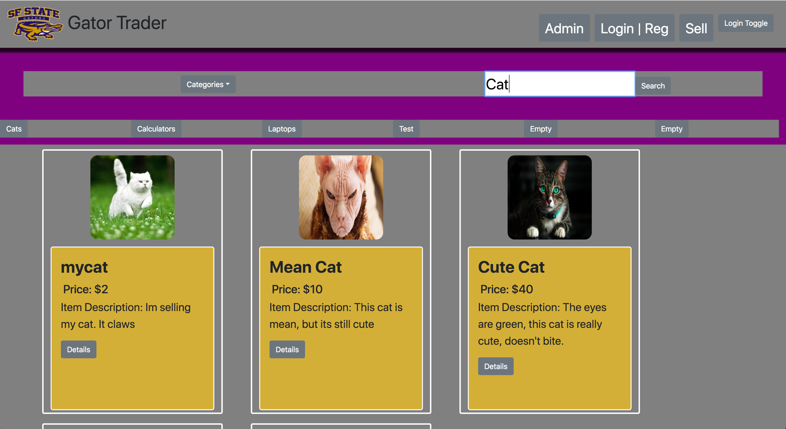Search results (NOTE: search parameters chosen by user have to be persistent)
* 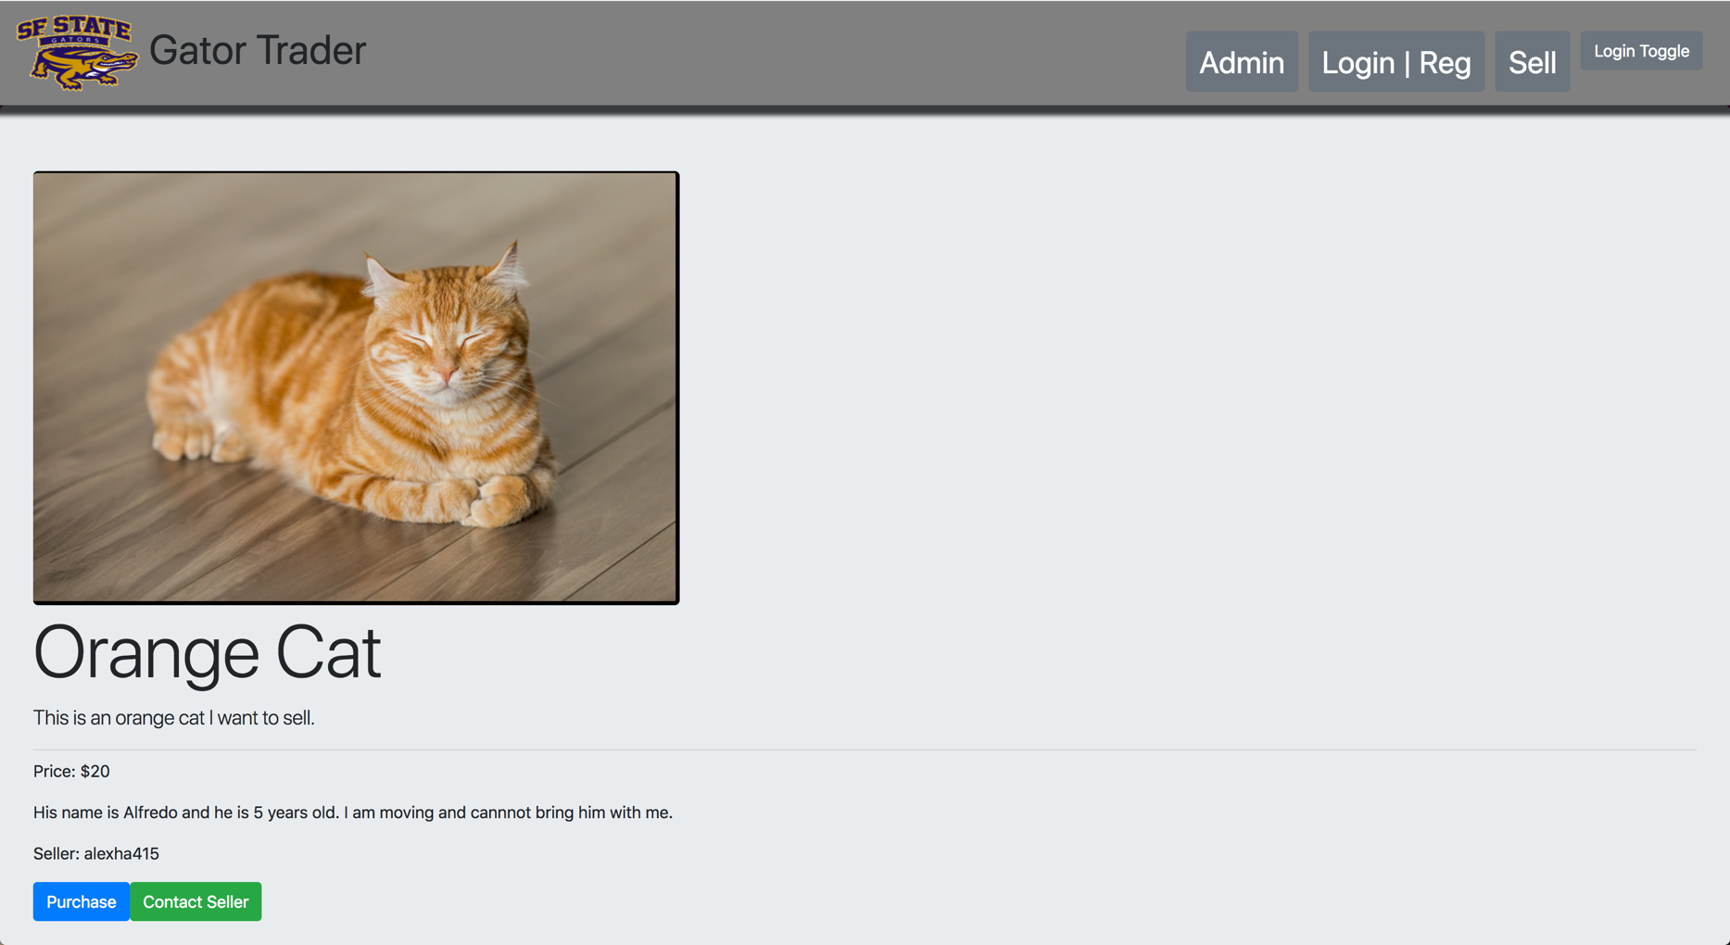Item details
* Messaging/contact seller

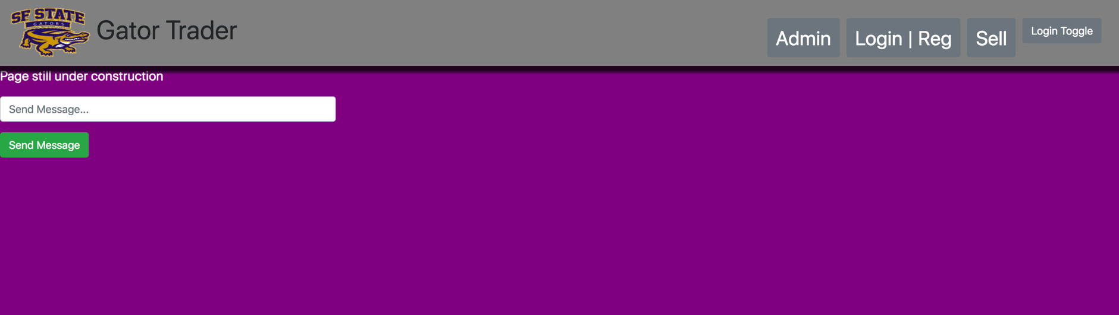

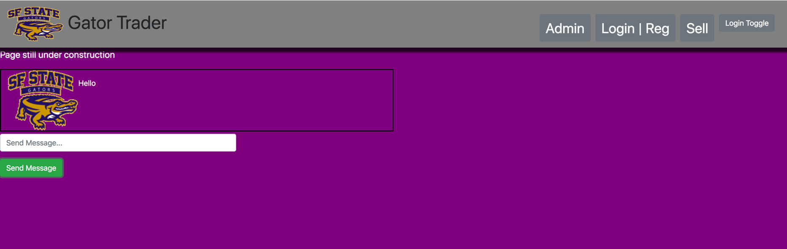

* Item posting

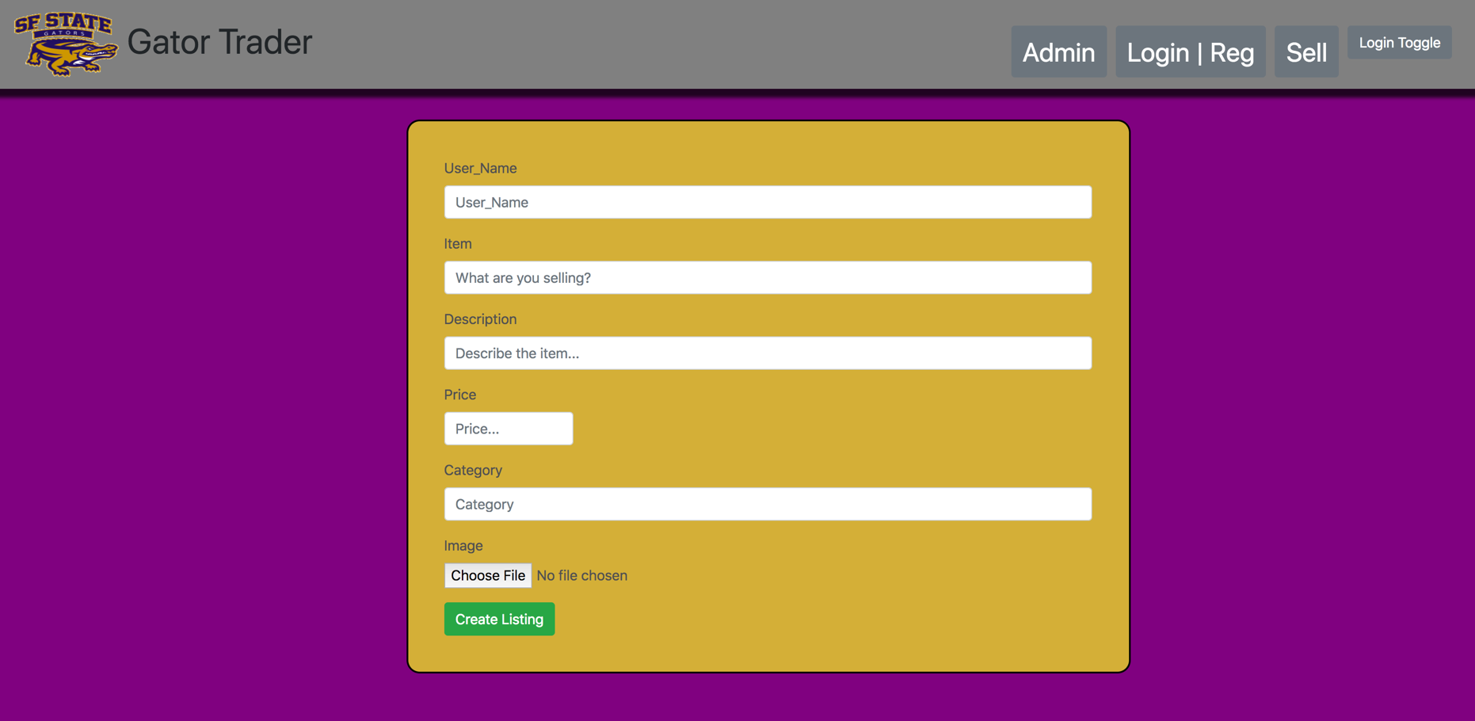

* 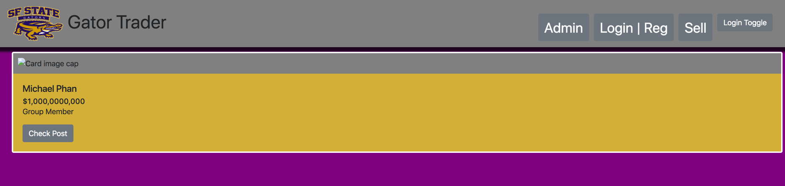Seller dashboard
* Admin dashboard

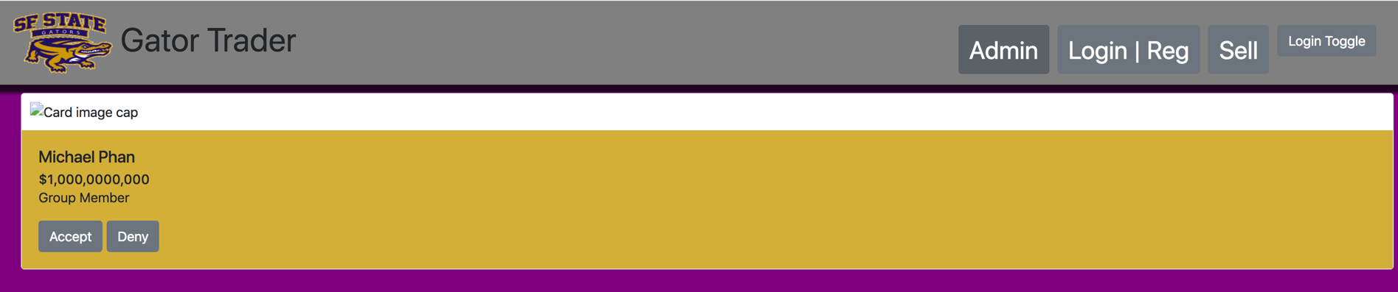

1. **List all major DB tables you have implemented and list their items**
   1. 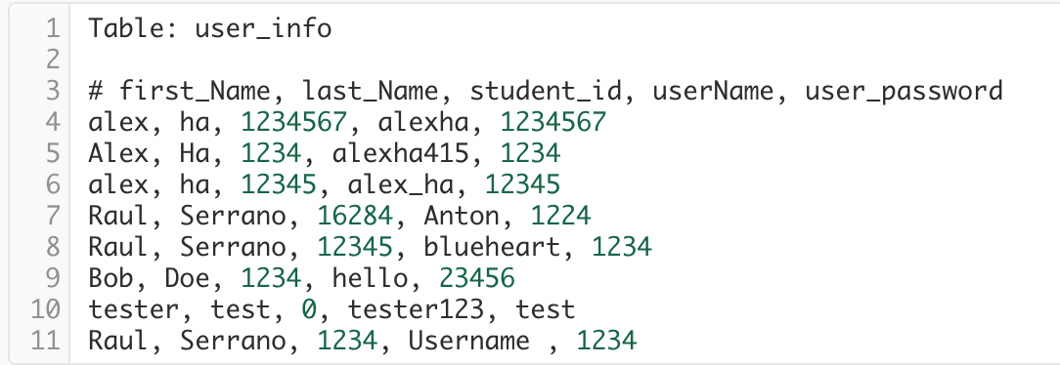
   2. 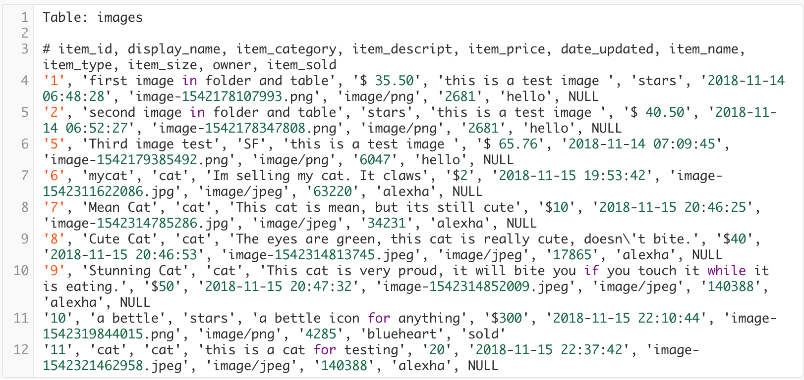
   3. 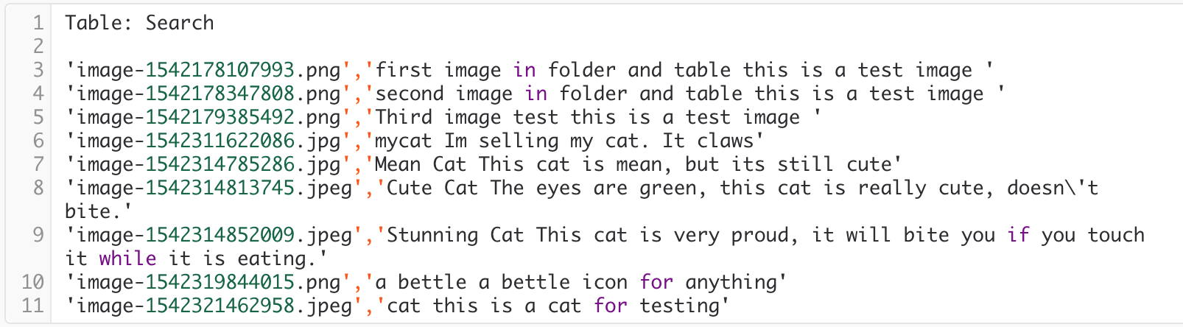
2. **List of requested P1 functions – provided by your CEO**

The flowing functions constitute minimal P1 list and you must implement and test them for December demo

* Home page
* Search(with search text validation)
* Search results
* Item details
* Log in and registration
* Item posting
* Message from buyer to seller
* Seller dashboard (for seller items and messages)
* Admin dashboard (backup is to use DB native admin tool but must show ability to approve posted images)